Structured Web Review Extraction and Opinion Summarization
Suke LI^{1,2}, Zhong CHEN^{1,}† , Liyong TANG¹ , Jianbin HU¹
¹ Institute of Software, School of Electronics Engineering and Computer Science, Peking University
Key Laboratory of High Confidence Software Technologies (Peking University),
Ministry of Education, Beijing 100871, China
²School of Software and Microelectronics, Peking University

Abstract
This paper focuses on structured Web review extraction and opinion summarization. An opinion extraction framework and a feature-opinion based opinion summarization algorithm (FOOSA) are proposed. Opinion related Web pages are first clustered according to their link and title similarities. Then reviews are extracted using tag patterns which are generated through one instance learning method. The extracted reviews are filtered basically according to some rules to remove meaningless symbols. At last, all reviews are segmented into feature-opinion sentences for continual processing. In opinion summarization, FOOSA uses feature-opinion pairs as keys to construct feature-opinion (FO) buckets. Then we use inter bucket reducing method based on information entropy to remove duplicated sentences in different buckets. FOOSA also carries out intra bucket clustering to select representative sentences from every bucket. FOOSA builds positive and negative text opinion summaries through our ranking method. A structured review extraction and opinion summarization system is implemented based on our approach. Our system provides not only text opinion summarization, but also Web based graphical overall sentiment summarization. Experiments show our review extraction and opinion summarization approaches are effective and promising.
Keywords: Opinion Extraction; Opinion Summarization; Opinion Mining

Introduction
In recent years, World Wide Web grows dramatically not only in size but also in online reviews. More and more websites, such as amazon.com, have provided services that facilitate Web users to publish their opinions about events, products and services. Web users can express their opinions in websites, forums, blogs, etc. Reviews on the Web are often organized as data records. One such record may contain information about review holder, publishing date, review data, etc. While several reviews may be in the same Web page and one or several Web pages may contain reviews about the same topic. These reviews are often generated by programs from backend databases. They often have the same HTML structure in one website. We decompose our review extraction and opinion summarization problem into following main subtasks: I. Extract reviews. II. Extract opinion sentences. III. Determine the polarity of opinion sentences. IV. Summarize opinions, including positive and negative opinion summarization. This paper focuses on subtask I and subtask IV.
Related work. In recent years, opinion mining has been studied extensively and has become a significant subject of research in the field of data mining [1]. But there is not so much work has been done on feature level opinion mining for Chinese reviews [2].
Regularly structured review data records can be extracted through wrapper induction, which usually requires manually labeling positive and negative examples to learn extraction rules. Softmeanly [3], WIEN [4], Stalker [5] are the examples of wrapper induction systems. However, it is time consuming and labor intensive to manually label data. There are also some researches focusing on automatic extraction approaches [6][7][8]. However, automatic extraction approaches may suffer from less accuracy and require manually identifying the items of interests [9].
Hu and Liu [10][11][12] ’s works are the early feature based opinion mining endeavor. In Hu and Liu’s works, opinion mining has three steps: mining product features, identifying sentiment of each sentence and summarizing the result. Turney et al. [13] uses point mutual information (PMI) [14] method to identify the sentiment of reviews. There are also some works [15][16] that use machine learning methods to identify the sentiment of a sentences. Opinion mining systems such as Review Seer [17], Red opal [18], Opinion Observer [12], OPINE [19] provide opinion summarization too. Unfortunately, most of these systems are mining product reviews and focus on the overall sentiment of opinions. Some of them do not provide text summarization such as [12], or some of them only show some simple opinion sentences for example [17]. Actually many reviews are not about products. They may contain opinions about restaurants, shops, services, etc. Such kind of opinion object may have hundreds of features. If an opinion mining system provides text and also graphical overall sentiment summarization according to features, an opinion viewer can easily find opinions and overall sentiment about the most important features. Second, it is common that we can find hundreds of opinion reviews about the same product or topic in a website. Because they are too many in number, and opinion reviews of the same topic may be distributed in several Web pages. An opinion viewer needs to click “next page” again and again to read all the opinions about the same topic. However, reading so many reviews is tedious and time consuming. Therefore text opinion summary for the top reasonable and important features of reviews about the same topic will be helpful for an opinion viewer to understand the overall sentiment. Furthermore, it is difficult to identify sentiment of every sentence correctly by machine because of the nature of human languages. But human can distinguish distinct sentiment more efficiently.
In this paper, we use one instance learning approach to extract review data records. Our approach needs less manual work than traditional wrapper induction but has promising precision. Furthermore our approach is robust, easy to use and implement. Using our approach, a user only needs to select and copy text snippets which he or she is interested in from a Web browser, then fill in a Web page form to generate extraction configuration files.
The major contributions of this paper are as follows:
1) We propose a Chinese opinion extraction framework. In this framework, Web pages are first clustered according to similarities of their links and titles instead of their body contents. Then reviews are extracted using tag patterns generated through one instance learning method. All extracted records are filtered basically according to some rules. Then, reviews are segmented into feature-opinion (FO) containing sentences prepared for continual processing.
2) A feature-opinion based opinion summation algorithm (FOOSA) is proposed. The algorithm uses feature-opinion (FO) as key to construct FO buckets. It selects representative sentences from every bucket through inner bucket clustering. At last, the algorithm builds positive and negative opinion summaries through our ranking method. Our opinion summarization system provides Web bar graph to show the distribution of the most important FO pairs. As far as we know, in China, until now, we do not find any opinion website which provides both text opinion summarization and feature-based graphical overall sentiment summarization services.
Note that our opinion summarization is different from traditional text summarization in three main aspects: 1) Our text opinion summarization focuses on FO pair bearing sentences, not for all the sentences appearing in the corpus; 2) Our text opinion summarization is overall sentiment summarization, so sentences in our summaries are ranked by FO distribution with positive and negative polarity classification. 3) Our summarization combines text opinion summarization with graphical overall sentiment summarization.

Opinion Extraction Framework
We use our vertical spider to crawl Web pages from opinion related websites. Our opinion extraction framework is only used to extract structured reviews. Fig. 1 presents the main modules of the framework. It includes four main parts:
1) Web Page Cluster. This module clusters all the same topic related opinion Web pages.
2) Review Extractor. We use tag patterns and link patterns to extract reviews in a Web page. A one instance learning method is implemented to extract these reviews because of its natural simplicity and high precision.
3) Review Cleaner. Reviews may contain meaningless symbols. Filtering out these noises is important for next step processing. The cleaner uses rules edited manually to filter the reviews.
4) Opinion Sentence Extractor.
Fig.1 Opinion extraction framework Fig. 2 A HTML tag tree

2.1. Opinion Web pages clustering
A Web page is opinion related if it contains opinions. There are many opinion irrelative Web pages in our database, such as navigation and index pages. We find that most of detailed opinion pages with the same topic in the same website have similar URLs structure and the same title if they have. Based on our observations we assume (1) Web pages which contain reviews and have the same URL pattern usually have the same HTML structure layout; (2) Web pages with the same topic have URLs that have the same structure. The clustering processing includes two steps. First, all the Web pages’ URLs are clustered by their domain names and similarities of URL path components. Then, all Web pages with the same title are clustered into a whole unit. For example, the URL http://www.dianping.com/shop/510047 may appear as a detailed page of an opinion topic. And http://www.dianping.com/shop/510047_p2#ur may be the second detailed page of the same opinion topic.

2.2. Review extraction and opinion sentence extraction
In order to get tag patterns, a tag tree is constructed from a review page instance. We use HTML tag tree to extract review records in the same review page. We adopt single instance learning method to extract records. Before extraction, a user must provide two or more text snippets which present the same kind of information but from different records. The extraction method includes two sub steps. 1) Get page record’s tag pattern; 2) Use the tag pattern to extract other records. Note that we do not use the automatic record extraction methods such as [6][7], the reasons are: 1) Our approach is robust, fast and simple; 2) The extracting precision and recall of our method for structure records are acceptable; 3) We have implemented tag pattern changing automatic detection mechanism and Web based visual extraction graphical interface which does not require a user knowing HTML syntax. Fig. 2 gives a HTML tag tree as an example. Note that each pair of HTML tags, such as <td></td>, is considered as one node in the tag tree.
A tag pattern is a sequence of tags with their vertical and horizontal positions. The vertical position of a tag is the level of a record in the tree. Actually, a vertical position can be expressed as a path component of the tag path from the root node to the tag. A horizontal position of a tag is its horizontal position comparing with its siblings. In Fig. 2, Record₀ and Record_{n} have the same HTML structure and they are sub trees of TABLE tag. Usually if a Web page contains several records, these records share one or more same tags in the tag tree with high probability. A tag path component in a tag path of a tree can be expressed as “tag: horizontal position” format. In Fig. 2, the tag string to get the parent node of the text node from Record₀ is TD:1-TR:0-TABLE:0-BODY:2-HTML:0, and the tag string of Record_{n} is TD:1-TR:n-TABLE:0-BODY:2-HTML:0. Note that here we use tag string from leaf to root, simplifying the procedure of string matching. We can see the TABLE tag is the nearest common tag for two tag strings. And TR tags obviously have different horizontal positions, one is 0, the other is n. The tag pattern string is TEXT:0-TD:1-TR:*-TABLE:0-BODY:2-HTML:0. Our task becomes to find the different nodes in the tag tree. If we select two text snippets as our extracting target instances. The tag string of text snippet₀ is Tag₁:p₀-Tag₂:p_{i}-…-Tag_{c-1}:p_{a}-Tag_{c}:p_{c}-…-Tag_{n}:p_{n}. The tag string for text snippet₁ is: Tag₁:p₀-Tag₂:p_{j}-…-Tag_{c-1}:p_{b}-Tag_{c}:p_{c}-…-Tag_{n}:p_{n}. Tag_{c-1}-p_{a} and Tag_{c-1}-p_{b} have the same vertical position in the tag string but different horizontal position p_{a} and p_{b} . Tag₂:p_{i} and Tag₂:p_{j} have the same vertical position but different horizontal position too. Other tags have the same name, the same vertical position and horizontal position. So, we get the last tag string pattern for snippet₀ and snippet₁ is: Tag₁:p₀-Tag₂:*-…-Tag_{c-1}:*-Tag_{c}:p_{c}-…-Tag_{n}:p_{n} , where we use symbol ‘*’ to be wildcard for different horizontal positions. Now we can use this tag pattern to match new tag strings and extract data.
The text snippets can get through a HTML browser. In our implementation, a text snippet must belong to a single tag node and is a continuous character stream. These snippets are stored in a XML configuration file. The file includes not only these extracting instances, but also information of how to deal with extracted data, for example the database table name and field names to store extracted data. The tag pattern extraction work can be done through our Tag Pattern Extractor that has Web based friendly graphical user interface. Tag Pattern Extractor can be easily used even a user do not know HTML syntax.
Opinion Sentence Extractor segments reviews into clauses. All clauses are sent to Part-of-Speech Tagging module. Then we use nouns or noun phrases as features and adjectives to produce FO sentences. There are two reasons for us to extract Chinese clauses instead of sentences from original reviews. First, we find that in our review corpus many Chinese sentences contain several clauses separated by commas can be looked as independent sentences and may express several different opinions for different features. Second, we hope our text opinion summaries are brief enough but do not contain too many long sentences. We extract nouns or noun phrases as features and adjectives as opinions. Adjective are normally used to express opinion in reviews [2][20]. We use ICTCLAS (Institute of Computing Technology, Chinese Lexical Analysis System) [21] to carry out Part-of-Speech tagging.

3. Opinion Sentence Sentiment Classification
There are two steps to determine sentiment orientation. The first step is to determine the polar orientation of opinion terms. The second step is to get the sentiment orientation of a sentence. Before opinion sentence sentiment classification, we first manually construct a polarity lexicon. If an opinion term is not in our polarity lexicon, we use the method proposed by Turney and Littman [22] to determine the semantic orientation of a term. In the second step, we apply some language related pattern rules to determine the sentiment of sentences. The PMI between two words x and y is:
$\text{PMI}(x,y)={\text{log}}_{2}\frac{p(x,y)}{p(x)p(y)}$ (1)
We use same method proposed by Turney and Littman [22] to get P(x) and P(y), the frequency of x, y and the co-occurrence P(x,y) of x, y through submitting queries to a general search engine. The semantic orientation of term t can be estimated to score SO(t) as shown:
$\text{SO}(t)=\sum_{t_{i}∈\text{Pos}}{\text{PMI}(t,t_{i})−\sum_{t_{i}∈\text{Neg}}{\text{PMI}(t,t_{i})}}$ (2)
where Pos is the positive term set, and Neg is the negative term set. If SO(t) > 0, t is positive. If SO(t) < 0, t is negative. To determine the sentiment of a sentence, some language related rules are applied. For example,
这个产品很贵.
This product is expensive.
The above sentence has negative sentiment. But if the sentence is changed into:
这个产品不是很贵.
This product is not expensive.
The sentiment of above sentence becomes positive. So a rule for our example is if there is a negative clue before a negative term, the polarity of the sentence is changed into positive polarity.

4. Opinion Summarization
We implement a FO based opinion summarization algorithm (FOOSA). The algorithm can be expressed as follows.
Step 1. Construct FO matrix. Every matrix element <f, o> is a bucket. There may be one or more sentences that contain feature f and opinion o, where f∈FS, o∈OS, FS is feature term set and OS is opinion term set. The system puts each sentence that contains one or more FO pairs into corresponding one or more buckets. Here it is possible for a sentence to be put into more than one bucket because a sentence may contain multi FO pairs. Fig. 3 is the example FO matrix.
Step 2. Inter bucket sentence reducing. This step uses information entropy to reduce duplicated sentences, if the sentence has more than one FO pairs. S is the sentence set in which every sentence has multi FO pairs. Suppose there are n buckets, p_{ji} is the portion of sentence after putting the sentences s, s∈S, into bucket_{j}. The same sentence in other bucket_{i} while i ≠ c is removed.
$c=\underset{0≤j<n}{\text{argmax}}(−\sum_{i=0}^{n−1}{p_{\text{ji}}{\text{log}}_{2}p_{\text{ji}}})$ (3)
Step 3. Intra bucket clustering. The sentences in one FO bucket are divided into three subsets: positive set, negative set and neutral set. The sentences that belong to the same FO bucket are put into one of the three sentiment sets according to sentiment classification. Then, the sentences in the same set are clustered according to similarities between them. We use (4) to measure the similarity between sentence a and sentence b. If two sentences have similarity value greater than 0.5, then they are put into the same cluster.
$\text{sim}(a,b)=\frac{|a∩b|}{\text{min}(|a|,|b|)}$ (4)
Step 4. Intra bucket representative sentence selection. In a bucket, from every sentiment set we find the cluster with the biggest size. Then we choose a sentence from the cluster as the cluster’s centroid. In this step, we still use (4) to choose a sentence a_{c} that has max total similarity values, where c is determined by (5). Every chose representative sentences put into positive, negative or neutral summary vector according to their sentiment.
$c=\underset{0≤i<n}{\text{argmax}}(\sum_{j=0}^{n−1}{\text{sim}(a_{i},a_{j}}))$ (5)
Step 5. Opinion sentence ranking. We use (6) to rank the summary sentence vectors.
$\text{Rank}(s)=s\text{.}\text{weight}+\frac{P_{f}×P_{o}}{n^{2}}$ (6)
Where s is the sentence to be ranked. The weight of s is the addition of the size of max positive cluster and the size of max negative cluster. P_{f} is the frequency of f, and P_{o} is the term frequency of o, where f and o are the bucket’s feature and opinion terms. The number n is just the total sentence number of all opinion sentences.
Fig. 3 A FO matrix Fig. 4 FO opinion sentence distribution

5. System Overview
Fig. 5 is the system overview. The system downloads Web pages containing review data records through a light weighted crawler implemented by ourselves. The crawler has simple regular expression matching mechanism to filter URLs extracted from downloaded Web pages. In fig. 5, Opinion Extractor, which includes Web Page Cluster, Review Extractor, etc., actually is the implementation of our opinion extraction framework. Web Page Cluster clusters the same topic and link structure Web pages. We also put every tag pattern generated by one instance learning method into out tag pattern library. When Review Extractor extracts records from a Web page, it first uses the Web page’s URL pattern to search pattern library. If a pattern is found, then it uses this pattern to extract reviews; otherwise, our system puts the Web page into waiting list, and a user can judge whether the pattern of the Web page is worth being further extracted.
In this paper, we implement sentiment opinion sentiment classification based on PMI method. The responsibilities of PMI Orientation Retrieval Module are to calculate PMI to get sentiment orientation of opinions. We implement software robots which can retrieval information automatically from a search engine. Here we submit queries to Baidu (www.baidu.com), one of most successful Chinese search engine in China, as our general search engine. Our PMI is calculated from tiles of Web pages, not from content body for sake of precision. For example, if we want to get the co-occurrence number of words “Beijing and China”. The query we submitted to Baidu is title: (Beijing China).

6. Experiments

6.1. Data
We downloaded thirty Chinese Web pages from dianpin.com (http://www.dianping.com). These data are about three topics: restaurant, shop and scenery spot. Then we use our opinion extraction framework to get opinions about three topics as table 1 shows. OP (Opinion precision) and FOP (feature-opinion precision) are calculated using (7) and (8).
$\text{OP}=\frac{\text{number} \text{of} \text{being} \text{judged} \text{as} \text{topic} \text{related} \text{opinion} \text{sentences}}{\text{total} \text{number} \text{of} \text{sentences} }$ (7) $\text{FOP}=\frac{\text{number} \text{of} \text{correctly} \text{associated} \text{FO} \text{pairs}}{\text{total} \text{number} \text{of} \text{FO} \text{pairs}}$ (8)
There are many FO pairs which are not valid because their opinion terms are not related to their features or not related to opinion topic. Fig. 4 is FO opinion sentence distribution. We do not show bucket with size less than two in fig. 4. We find three persons who are familiar with our three topics and let them to select reasonable FO pairs.

Table.1 Data
Data | RN | SN | CCN | OP | FON | FOSN | VFOPN | FOP
Restaurant | 100 | 1622 | 13308 | 0.33 | 177 | 210 | 116 | 0.66
Shop | 100 | 1944 | 16005 | 0.38 | 214 | 182 | 131 | 0.61
Scenery Spot | 100 | 1906 | 15538 | 0.35 | 181 | 148 | 112 | 0.62
Note: RN: Review Number; SN: Sentence Number; CCN: Chinese Character Number; OP: Opinion precision; FON: Feature-opinion pair number; FOSN : Sentence Number with Feature-opinion pairs; VFOPN: Valid Feature-opinion Pair Number; FOP: Feature-opinion Precision.

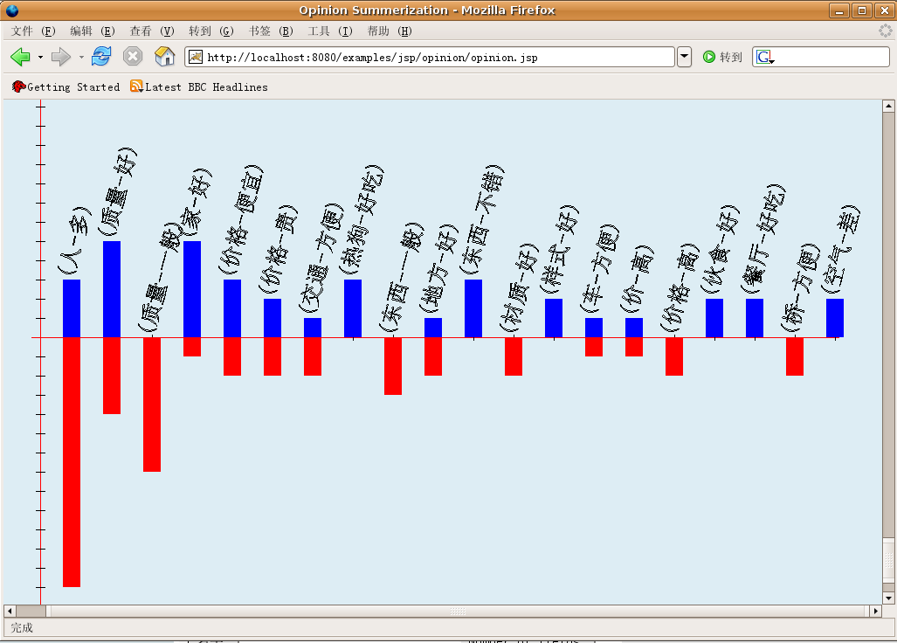
Fig. 5 System overview Fig. 6 A graphical overall sentiment summarization example
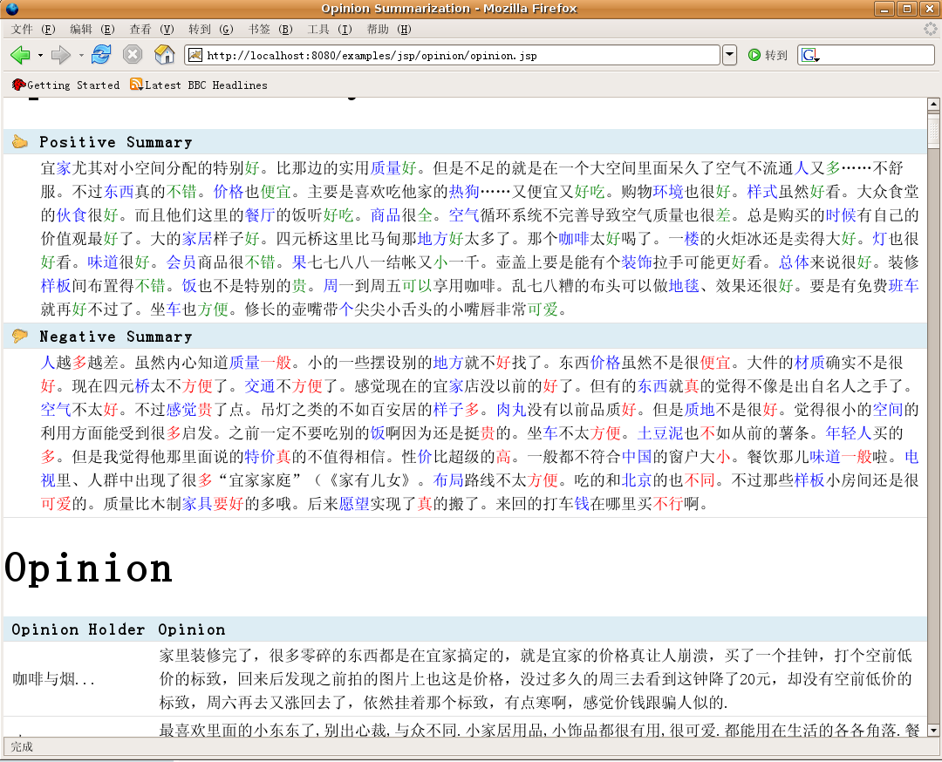
Fig. 7 A text opinion summarization example (for our shop data)

6.2. Opinion summarization and evaluation
Fig. 6 is a Web based graphical overall sentiment summarization example. In the graph, red color represents as negative sentiment and blue color as positive sentiment. The height of a bar in the graph is the total number of sentences which have correspondent FO pair with positive or negative sentiment. FO pairs are also ranked. In our system, a user can choose how many FO pairs should be displayed in the graph. The bar graph method is inspired by Opinion Observer [12].
In fig. 7, an opinion text summarization example is showed. In this example, there are thumb up and thumb down symbols before the positive and negative summaries. The sentences in the summaries are the ranked sentences produced by FOOSA. Blue color and green color are colors for positive FO pairs, and blue color and red color are for negative FO pairs. Note that we do not display neutral opinions sentence in our example.
We find three persons who are familiar with our three topics. They compare the original reviews with our summaries and judge 1) whether sentences in summary are related to opinion topic; 2) whether these sentences should be ranked as top n; 3) whether the sentiment classification of the sentence is correct.
$$\text{precision}@n=\frac{\text{number} \text{of} \text{being} \text{top} n \text{topic} \text{related} \text{sentences} \text{with} \text{correct} \text{sentiment} \text{classification} }{n}$$
Table.2 Precision of opinion summary
Data |  | Restaurant |  |  | shop |  |  | Scenery Spot
Precision | Top N | @10 | @20 | @30 | @10 | @20 | @30 | @10 | @20 | @30
Precision | Positive | 0.90 | 0.85 | 0.87 | 0.80 | 0.75 | 0.73 | 0.70 | 0.65 | 0.60
Precision | Negative | 0.80 | 0.60 | 0.57 | 0.90 | 0.85 | 0.63 | 0.50 | 0.50 | 0.40
Precision | Average | 0.85 | 0.73 | 0.72 | 0.85 | 0.80 | 0.68 | 0.60 | 0.58 | 0.50
Total Average Precision |  | @10 | 0.77 |  | @20 | 0.70 |  | @30 | 0.63
We use average FOP as our baseline precision. The average of three @10 precisions is 0.77. It is greater than average OP which is 0.35 and average FOP which is 0.63. The results show our text opinion summarization approach is effective and promising.

7. Conclusions and Future work
In this paper an opinion extraction framework and a feature-opinion based opinion summation algorithm (FOOSA) are proposed. A structured review extraction and summarization system is implemented. Our system not only provides text opinion summarization, but also Web based feature-opinion graphical overall sentiment summarization. Experiments show our review extraction and opinion summarization approach is effective and promising. In the future, we hope to find better approaches on improving precision of feature-opinion identifying and precision of sentiment classification. We also expect to find novel opinion summarization algorithms with higher accuracy.

Acknowledgement
The authors are grateful for the anonymous reviewers who made constructive comments.

References
- Dongjoo Lee, Ok-Ran Jeong and Sang-goo Lee. Opinion mining of customer feedback data on the web. Proc. of the 2nd international conference on Ubiquitous information management(ICUIMC-2008) and communication, ACM Press, 2008, pp.230-235.
- Qi Su, Xinying Xu, Honglei Guo, Zhili Guo, Xian Wu, Xiaoxun Zhang and Bin Swen. Hidden Sentiment Association in Chinese Web Opinion Mining. Proc. of the 17th international conference on World Wile Web (WWW’08), ACM Press, 2008, pp.959-968.
- Hsu, C.-N. and Dung, M.-T. Generating finite-state transducers for semi-structured data extraction from the Web. Information Systems, 1998, 23(8): 521-538.
- Kushmerick and N. Wrapper induction: efficiency andexpressiveness. Artificial Intelligence, 2000, 118:15-68.
- Muslea, I., Minton, S. and Knoblock, C. A hierarchical approach to wrapper induction. ACM Press, Agents-99, 1999, pp.190-197.
- Liu, B., Grossman, R. and Zhai, Y. Mining data records from Web pages. KDD-03, ACM Press, 2003, pp.601-606.
- Yanhong Zhai and Bing Liu, Web data extraction based on partial tree alignment. Proc. of the 14th international conference on World Wide Web, ACM Press, 2005, pp.76-85.
- Chang, C. and Lui, S-L. IEPAD: Information extraction based on pattern discovery. ACM Press, WWW-10, 2001, pp.681-688.
- Yanhong Zhai and Bing Liu. Extracting Web Data Using Instance-Based Learning. World Wide Web, Kluwer Academic Publishers, 2007, 10(2):113-132.
- M. Hu and B. Liu. Mining and summarizing customer reviews. Proc. of the ACM SIGKDD International Conference on Knowledge Discovery and Data Mining (KDD-2004), ACM Press, 2004, pp.61-769.
- M. Hu and B. Liu. Mining opinion features in customer reviews. Proc. of Nineteeth National Conference on Artificial Intellgience (AAAI-2004), 2004, pp.755-760.
- Liu, B., Hu, M., and Cheng, J. Opinion observer: analyzing and comparing opinions on the Web. In Proceedings of the 14th international Conference on World Wide Web(WWW '05), ACM Press, 2005, pp.342-351.
- Turney and P. D.. Thumbs up or thumbs down?: semantic orientation applied to unsupervised classification of reviews. Proc. of the 40th Annual Meeting on Associationfor Computational Linguistics, ACM Press, 2002, pp.417-424.
- M. C. Thomas and J. A. Thomas, Elements of Information Theory. Wiley-Interscience, 1991.
- Pang, B. and Lee, L. 2004. A sentimental education:sentiment analysis using subjectivity summarization based on minimum cuts. Proc. of the 42nd Annual Meeting on Association for Computational Linguistics, ACM Press, 2004, pp.271-278.
- Pang, B., Lee, L., and Vaithyanathan, S. Thumbs up?: sentiment classification using machine learning techniques. In Proceedings of the Acl-02 Conference on Empirical Methods in Natural Language Processing - Volume 10 Annual Meeting of the ACL, ACM Press, 2002, pp.79-86.
- Dave, K., Lawrence, S., and Pennock, D. M. 2003. Mining the peanut gallery: opinion extraction and semantic classification of product reviews. Proc. of the 12th international Conference on World Wide Web (WWW '03), ACM Press, 2003, pp.519-528.
- Scaffidi, C., Bierhoff, K., Chang, E., Felker, M., Ng, H., and Jin. Red Opal: product-feature scoring from reviews. Proc. of the 8th ACM Conference on Electronic Commerce, ACM Press, 2007, pp.182-191.
- Popescu, A. and Etzioni, O. Extracting product features and opinions from reviews. Proc. of the Conference on Human Language Technology and Empirical Methods in Natural Language Processing, ACM Press, 2005, pp.339-346.
- V. Hatzivassiloglou and K. McKeown. Predicting the sematic orientation of adjective. Proc. of the 35th Annual Meeting of the ACL and the 8th Conference of European Chapter of the ACL, ACM Press, 1997, pp.174-181.
- http://www.nlp.org.cn/project/project.php?proj_id=6.
- Turney, P. D. and Littman, M. L. Measuring praise and criticism: Inference of semantic orientation from association. ACM Trans, Inf. Syst, 2003, 21(4):315-346.

† Corresponding author. Email addresses: lisuke@infosec.pku.edu.cn (Suke LI)

